INTERNATIONAL INDIAN OCEAN SCIENCE CONFERENCE 2020, GOA
- SIDE MEETINGS

BOGMALLO BEACH RESORT
Bogmalo Road, Bogmalo, South Goa, India

22-26 March 2020

INFORMATION BOOKLET

[DRAFT / PROVISIONAL]
[Updates posted on https: ]

(Version 2: Updated 29 October 2019 by Sarah Gardner)
- OVERVIEW
The IIOSC 2020 Side Meetings will take place following the International Indian Ocean Science Conference, 16-20 March 2020, Goa (IIOSC 2020) (https://iiosc2020.incois.gov.in/). The IIOSC 2020 aims to review the progress and scientific knowledge resulting from the Second International Indian Ocean Expedition (IIOE-2) (2016-2020). The different facets of the Indian Ocean, outstanding issues and knowledge gaps considered at the Conference will be used to inform discussions during the IIOSC 2020 Side Meetings.

- HOSTS
National Centre for Polar and Ocean Research (NCPOR), Vasco-da-Gama, Goa, India
Contact: Dr. M. Ravichandran, Director, NCPOR, mravi@ncaor.gov.in,
Mobile xxxxxxxxxx, Office +91 832 2520876 / 2525511
UNESCO Intergovernmental Oceanographic Commission Perth Programme Office (IOC PPO), Perth, Western Australia, Australia
Contact: Dr Nick D’Adamo, Head IOC PPO, nick.dadamo@bom.gov.au,
Mobile +61 409 680 247 / Office +61 8 9226 2899

- SIDE MEETING SPONSORS
On behalf of all groups meeting following the IIOSC 2020, the organising committee would like to acknowledge the National Centre for Polar and Ocean Research, Ministry of Earth Sciences, Government of India and UNESCO IOC PPO as major sponsors and supporters of the 2020 IIOSC Side Meetings.

We also wish to acknowledge:

- MEETINGS OVERVIEW
See Attachment 1 for the meetings schedule. In summary, the integrated set of meetings comprise:
- 4th meeting of the Second International Indian Ocean Expedition (IIOE-2) Steering Committee;
- 16th annual meeting of the Indian Ocean Global Ocean Observing System Regional Alliance (IOGOOS);
- 16th annual meeting of the CLIVAR/IOC-GOOS Indian Ocean Region Panel (IORP);
- 10th annual meeting of Sustained Indian Ocean Biogeochemistry and Ecosystem Research (SIBER) of IMBER/IOGOOS;
- 10th annual meeting of the Indian Ocean Observing System (IndOOS) Resource Forum (IRF) of IOGOOS;
- IOC Regional Committee for the Central Indian Ocean (IOCINDIO).

- MEETINGS VENUE
Main Venue: Bogmallo Beach Resort, Bogmalo Rd, Bogmalo, South Goa, India.
Conference Rooms: Meteora Hall, Coral 1 and Coral 2.
The Bogmallo Beach Resort is very close to Vasco da Gama and the Goa International Airport.

Please note: the IIOSC 2020 Side Meetings are to be held at a different location in Goa (Bogmalo, South Goa) to the IIOSC 2020 (which will be held at the National Institute of Oceanography, Dona Paula, Goa)

See Attachment 2 for a location map of the Bogmallo Resort, Bogmalo, South Goa.

- AIR TRAVEL AND TRANSPORT
Goa International Airport (or Dabolim Airport), is served directly by domestic flights and a handful of international flights. Generally, you'll have to fly into a major city such as Mumbai or Delhi and change to a domestic flight with airlines such as Jet Airways, Air India, SpiceJet or IndiGo. The airport arrivals hall is equipped with currency exchange, ATMs and a prepaid taxi counter.
- TRANSFERS
The Bogmallo Beach Resort is a 10-minute drive from the airport. If coming direct from the Goa International Airport to Bogmallo Beach Resort, the special group booking rate includes Airport Transfers (see Section 9).
For participants attending the IIOSC 2020 in Dona Paula, Goa from 16-20 March a shuttle bus will be arranged for Saturday 21 March at X location(s) at X time(s) to collect participants and transport them to and transferring to the Bogmallo Beach Resort [TBC]. Alternatively, delegates can organise their own transport to the Resort.
- VISAS
Almost everyone (except citizens of Nepal and Bhutan) needs a visa before arriving in India. Your passport should be valid for at least six months beyond your intended stay and have 2 blank pages.
Citizens from most countries are able to apply online for a 60-day double entry e-Visa or Electronic Travel Authority for arrival at Goa, Delhi, Mumbai and numerous other Indian airports.
Participants are kindly advised to check their visa requirements as soon as possible to allow adequate time for approval processes.

- ACCOMMODATION
Accommodation bookings are the responsibility of participants. Participants are kindly advised to make their hotel and flight bookings as soon as possible. The following accommodation notes are for your reference and guidance. Please note that they may be subject to change at the time of booking.
Hotel: Bogmallo Beach Resort, Bogmalo Rd, Bogmalo, South Goa, India
Phone: +91 0832 6729100
Reservations: +91 0832 6729142 / 3
Website: https://www.bogmallobeachresort.com

Special Group Rates:
- Single sea facing room: Rs. 6400 plus GST per room per night on AP (~$89 USD).
- Double sea facing room: Rs. 7400 plus GST per room per night on AP (~$104 USD).

Note:
- Check-in time is 2pm, Check-out time is 12pm.
- The room rates include a buffet Breakfast, buffet Lunch and buffet Dinner as per hotel standard buffet layout.
- Please complete the Bogmallo Beach Resort Booking Form and return to the resort directly (Attachment 3).

- REGISTRATION
PLEASE NOTE THAT REGISTRATIONS CLOSE ON [TBC] 2020.
To register for IIOSC 2020 Side Meetings please click:
[webpage to created]
This will direct you to the Eventbrite website, where you will be able to register for your respective chosen days of attendance, on a day-by-day basis.
For catering purposes, please indicate if you have any dietary requirements.
- INVITATION LETTERS
For those participants requiring an invitation letter to facilitate attendance at the IIOSC 202O Side Meetings please contact [TBC] and they will be pleased to provide you with a letter.
We recommend that you contact [TBC] as soon as possible to allow sufficient time for the invitation letters to be drafted.
- MEETING PARTICIPATION ADVICE (see full meeting schedule at Attachment 1)
- For the IIOSC 2020 Side Meetings (IIOE-2, IOCINDIO, IndOOS, IRF, IORP, SIBER & IOGOOS), please note that non-affiliates (i.e. non-members) of those groups may be accepted into some of the meetings - as observers. This is in order to promote opportunistic collegiate interaction, relationship building and identification of synergies and opportunities for collaborations between the international groups that are meeting and local/regional stakeholders that may be present during the week.
- However, please also note that some of the meetings will be closed and will only involve group 'members' – this is due to the nature of discussions to take place, being either of a business or private nature.
- To enquire about possible attendance at individual meetings please refer (by email) any requests for attendance as an observer to the 'principal contact persons' listed in the table below for the respective meetings in question.
Date (2020) | Meeting/Event | Principal contact person for general information on the meeting/event of the day
22 Mar | IIOE-2 SC4 | Nick D'Adamo  nick.dadamo@bom.gov.au
 | IIOE-2 SC4
23 Mar | IIOE-2 SC4 | Nick D'Adamo  nick.dadamo@bom.gov.au
 | IIOE-2 SC4
24 Mar | IORP-16 | Jing Li  jing.li@clivar.org  Roxy Koll  roxy.koll@noaa.gov  Lisa Beal  lbeal@rsmas.miami.edu
 | SIBER-10 | Greg Cowie  Dr.Greg.Cowie@ed.ac.uk  Raleigh Hood  rhood@umces.edu
25 Mar | IRF-10 | Sidney Thurston  sidney.thurston@noaa.gov  Nick D'Adamo  nick.dadamo@bom.gov.au
 | IOCINDIO | M A Atmanand (Atma)  atma@niot.res.in  Justin Ahanhanzo (IOCINDIO Secretariat)  J.Ahanhanzo@unesco.org
26 Mar | IOGOOS-16 | Satheesh Shenoi  shenoi@incois.gov.in  Nagaraja Kumar M  raja@incois.gov.in
 | Contingency slots

- AGENDAS
Detailed agendas for all meetings are being prepared by the respective co-chairs/secretariats. Please regularly visit the IIOE-2 website at http://www.iioe-2.incois.gov.in/IIOE-2/IIOSC2019.jsp to directly access available agendas as they become available. If you have any questions about the agendas, please direct them to the appropriate co-chairs/secretariats (see the names and emails of those personnel in the table of Section 10, above).

- INTERNET & POWER
Wifi Internet will be available at the Bogmallo Beach Resort.
In India the standard voltage is 230V and the standard frequency is 50 Hz. Conference participants (e.g. from Japan, USA and Canada, which use 100/120V 50/60Hz) may need to consider the need for a voltage converter. The power plugs and sockets are of type C, D and M.
- Type C: also known as the standard "Euro" plug. This socket also works with plug E and plug F.
- Type D: mainly used in India, Sri Lanka, Nepal, and some African countries. This socket only works with plug D.
- Type M: looks like plug D, but with larger pins. This socket only works with plug M.
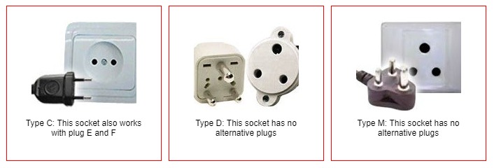
Note:
- Participants are recommended to bring appropriate Power Adapters to enable use of wall sockets.
- Meeting co-chairs/secretariats will be advised of the AV facilities at the venue. Please be mindful of the need to bring the appropriate adaptors to ensure you can connect your laptops to enable you to run your meeting sessions.
- Kindly keep phones on silent during sessions.
- Please note that power outlets may be limited within the meeting rooms. It is recommended you come with your laptop and other electronic devices charged. Thank you.

- CATERING
For each day of meetings, registered participants will be provided with morning tea and afternoon tea, and a buffet breakfast, lunch and dinner as included in the hotel room rates. Vegetarian and vegan options will be provided [TBC]. Please complete the online registration to identify your dietary requirements [TBC].

ATTACHMENT 1: Meeting Schedule
IIOSC 2020 Side Meetings

 | Sunday 22 March | Monday 23 March | Tuesday 24 March |  | Wednesday 25 March | Thursday 26 March
0800-0900 | Registration | Registration | Registration |  | Registration | Registration
0900-1030 | IIOE-2 SC4 | IIOE-2 SC4 | IORP-16/SIBER-10 |  | IRF-10 | IOGOOS-16  (requires all group leaders to attend [IIOE-2, IORP, SIBER, IRF])
1030-1100 | Tea/Coffee | Tea/Coffee | Tea/Coffee |  |  | Tea/Coffee
1100-1230 | IIOE-2 SC4 | IIOE-2 SC4 | IORP-16/SIBER-10 |  | IRF-10 | IOGOOS-16  (requires all group leaders to attend [IIOE-2, IORP, SIBER, IRF])
1230-1330 | Lunch | Lunch | Lunch |  | Lunch | Lunch
1330-1500 | IIOE-2 SC4 | IIOE-2 SC4 | SIBER-10 | IORP-16 | IOCINDIO | Contingency session slot
1500-1530 | Tea/Coffee | Tea/Coffee | Tea/Coffee |  |  | Tea/Coffee
1530-1700 | IIOE-2 SC4 | IIOE-2 SC4 | SIBER-10 | IORP-16 | IOCINDIO | Contingency Session slot
Evenings | Free evening  *unless sponsor identified (TBA) | Free evening  *unless sponsor identified (TBA) | Free evening  *unless sponsor identified (TBA) |  | Free evening  *unless sponsor identified (TBA) | Free evening

ATTACHMENT 2: Maps
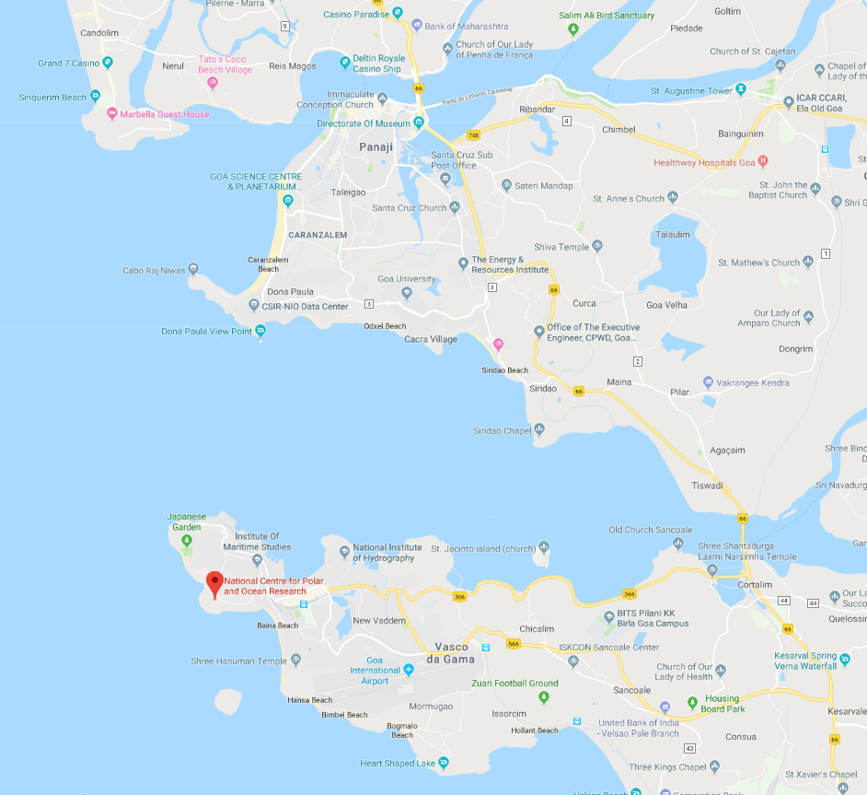
IIOSC 2020 Conference venue
IIOSC 2020 Side Meetings venue

Figure 1. Overall map showing key locations, Goa, India (source: Google Maps, 2019)

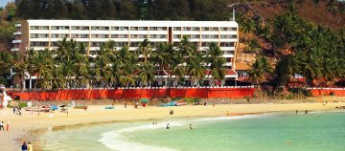
Figure 2: Bogmallo Beach Resort, Bogmalo

ATTACHMENT 3: Bogmallo Beach Resort Booking Form

Guest Name:
Special Rates:
Single sea facing room: Rs.6400 plus GST per room per night on AP
Double sea facing room: Rs.7400 plus GST per room per night on AP
NOTE: Kindly book room from previous night in case of early morning check in.
Check-in date: | Flight no. for airport pick up:
Check-out date: | Flight no. for airport drop:
Number of rooms: | Booking Code: NCPOR
No of Adult(s):
NOTE: Kindly fill booking form and send it to virender@bogmallobeachresort.com
Kindly fill the credit card details on Page 2 to guarantee your booking and the final amount can be paid on arrival, Same card will be charged if the booking is cancelled within cancellation policy

The above rate is inclusive of:
- AC Airport transfers
- Welcome refresher on arrival
- Stay in well-appointed sea facing AC rooms
- Buffet breakfast, Buffet Lunch & Buffet Dinner as per hotel standard buffet layout
- Use of in room Tea/Coffee dispenser replenished once daily. Any additional requirement would be at an extra cost
- Use of Swimming Pool (with proper swim wear) and gymnasium

Check in time at the resort is 1400 hours and check out time is 12 noon. Kindly book room from previous night in case of early morning check in.
CANCELLATION POLICY:
No cancellation charge in case the group is cancelled 60 days from the date of travel.
25% cancellation charges levied in case the group is cancelled 60 days from the date of travel.
50% Cancellation charges levied in case the group is cancelled 45 days before the date of check in.
Full cancellation charge in case of release of rooms 30 days from the date of travel
Bogmallo Beach Resort
Credit Card Authorisation Form

Dear Sir/ Madam

This form has been created in order to allow you to have third party expenses charged to your credit card. Please provide all the information requested below to ensure prompt processing of your application. We ask you to please sign and date the form before submission.

Card Holder Information

Name as it appears on the credit card: ___________________________________

Card type: Visa MC Amex
Account type: Individual (personal credit card)
Corporate I Company Name: ____________________________________
Account number: ___________________________________________ Exp. date: _________
Address : _____________________________________________________________________
City, State and Zip: _____________________________________________________________
Guest Information:
Guest name : __________________________________________________________________
Company : _____________________________________________________________________
Phone number: ___________________ Fax or alternate number: _______________________
Arrival date: _______________________ Departure date: ______________________________
Relation to cardholder: Relative Friend Business Associate Other: __________
Rate Information and Approval Charges
Rupees (Rs)
I certify that all information is complete and accurate. The details mentioned above are to guarantee the booking and final amount will be paid on arrival to hotel.
Cardholder name: ________________________________________________________
Cardholder signature: ___________________________ Date : ___________
Warm Regards,
Virender Singh | National Head - Sales & Marketing | Bogmallo Beach Resort |
P.O Box- Bogmallo ,Goa - 403806 | Mobile No: 07709790669 | Tel: 0832-7131000/7131248
E-Mail : virender@bogmallobeachresort.com

ATTACHMENT 4: Information on Goa and Bogmalo

Goa and Bogmalo
Goa is located on the west coast of India and is spilt into two districts North and South Goa. Panaji is the state capital, while Vasco da Gama is the biggest city. Goa is known for its golden sandy beaches that stretch along the coast of the Arabian Sea. As a former Portuguese colony, this cultural influence is evident in Goa's world heritage architecture. Goa is also renowned for its places of worship and its rich biodiversity of flora and fauna.

Bogmalo is a small village located in a bay with around 2 kilometres of sandy beach. It is located 4 kilometres from Goa International Airport and 9 kilometres from Vasco da Gama. The best time to visit is between November and March, with April and May being very hot (https://www.tourism-of-india.com/goa/).

Things to See and Do
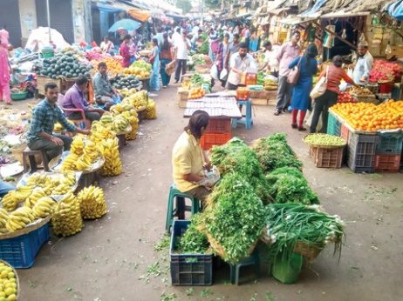 | 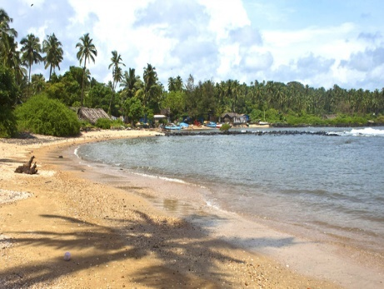 | 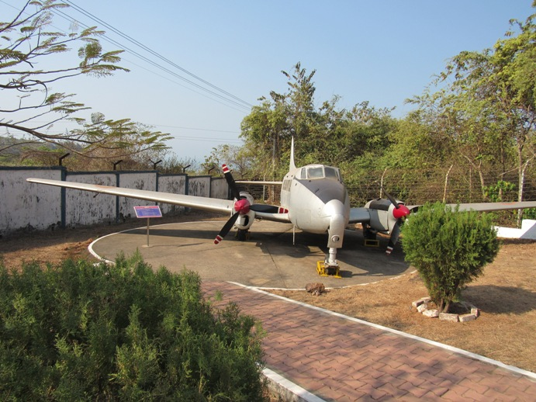
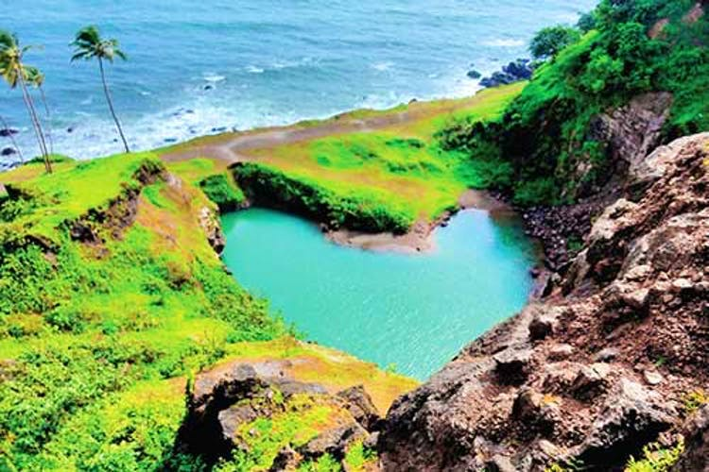 | 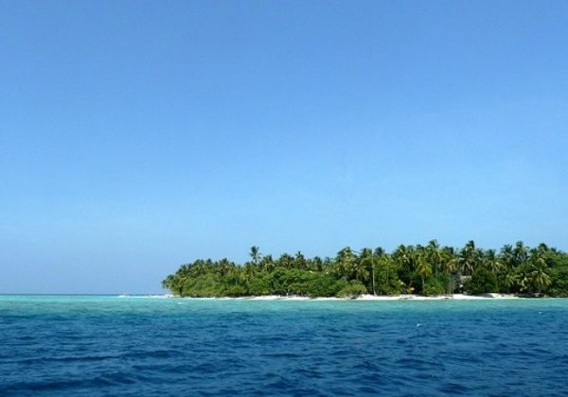 | 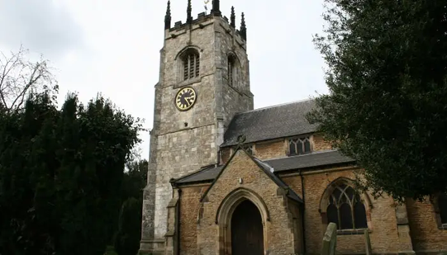
Left to right: Vasco Municipal Market, Hollant Beach, Naval Aviation Museum, Heart Shaped Lake, Pequeno Island, St Andrew's Church.

For further information on other sights and tours while in Goa, please refer to the IIOSC 2020 webpage or the Tourism of India website.

